The following is the code I have written by now.

%% differential only serdes channel simulation

%% setup channel parameters

bit_rate = 28e9; %bits-per-second

bit_time = 1/bit_rate; % second

samples_per_bit = 64;

sampling_rate = bit_rate * samples_per_bit;

sample_step = bit_time / samples_per_bit;

seqlength = 10000; % length of random sequence bits

z0_t = input('Enter the reference impedance: ');

z0_r = input('Enter the terminal impedance: ');

%% setup IBIS AMI model path and filename

modelpath = 'C:\Users\younger\Documents\MATLAB\_develop\_chasim\Qlogic_Cetus_wrk';

tx_amifilename = 'g28_28g_tx.ami';

rx_amifilename = 'g28_28g_rx.ami';

tx_dllfilename = 'G28_28G_Tx_32.dll';

rx_dllfilename = 'G28_28G_Rx_32.dll';

tx_amifile = fullfile(modelpath, tx_amifilename);

rx_amifile = fullfile(modelpath, rx_amifilename);

tx_dllfile = fullfile(modelpath, tx_dllfilename);

rx_dllfile = fullfile(modelpath, rx_dllfilename);

addpath(modelpath)

%% get channel impulse response

addpath('C:\Users\younger\Documents\MATLAB\_develop\_chasim\impulse_response_oct2012');

addpath('C:\Users\younger\Documents\MATLAB\_develop\_chasim\SYZ_conversions');

s4ppath = 'C:\Users\younger\Documents\MATLAB\_develop\_chasim\Qlogic_Cetus_wrk';

ads_s4pname = 'spara1.s4p';

ads_s4pfile = fullfile(s4ppath, ads_s4pname);

ads_s4pstruct = tsnpimporti(ads_s4pfile);

znp1 = s2z(ads_s4pstruct);

mv = [1 0 -1 0; 0 1 0 -1; 0.5 0 0.5 0; 0 0.5 0 0.5];

mi = [0.5 0 -0.5 0; 0 0.5 0 -0.5; 1 0 1 0; 0 1 0 1];

for i=1:800

zm(:,:,i) = (mv * znp1.data(:,:,i)) * inv(mi);

end

zdd = zm(1:2,1:2,:);

u = [1 0;0 1];

zt = [-2*z0_t 0;0 -2*z0_r];

for i=1:800

Htrans(:,:,i) = inv(u - zt * inv(zdd(:,:,i))); % channel transfer function H(jw)

end

hac_t = ifft(Htrans); % channel impulse response hAC(t)

channel_impres = hac_t(:,1,:);

channel_impres = reshape(real(channel_impres), 1, 1600);

tinterp = 0:sample_step:1599*sample_step;

plot(tinterp, channel_impres);

%% IBIS AMI_Init

%[ impresotx, amiparotx, mhtx, initmsgtx, errtx, errmsgtx ] = amiinit_1207a(tx_amifile, tx_dllfile, channel_impres, sample_step, bit_time);

% plot(tinterp, channel_impres,'--rs', tinterp, impresotx','-.bo');

% title('Impulse Response');

% xlabel('Time');

% ylabel('Impulse');

% legend('Whatever');

% grid on;

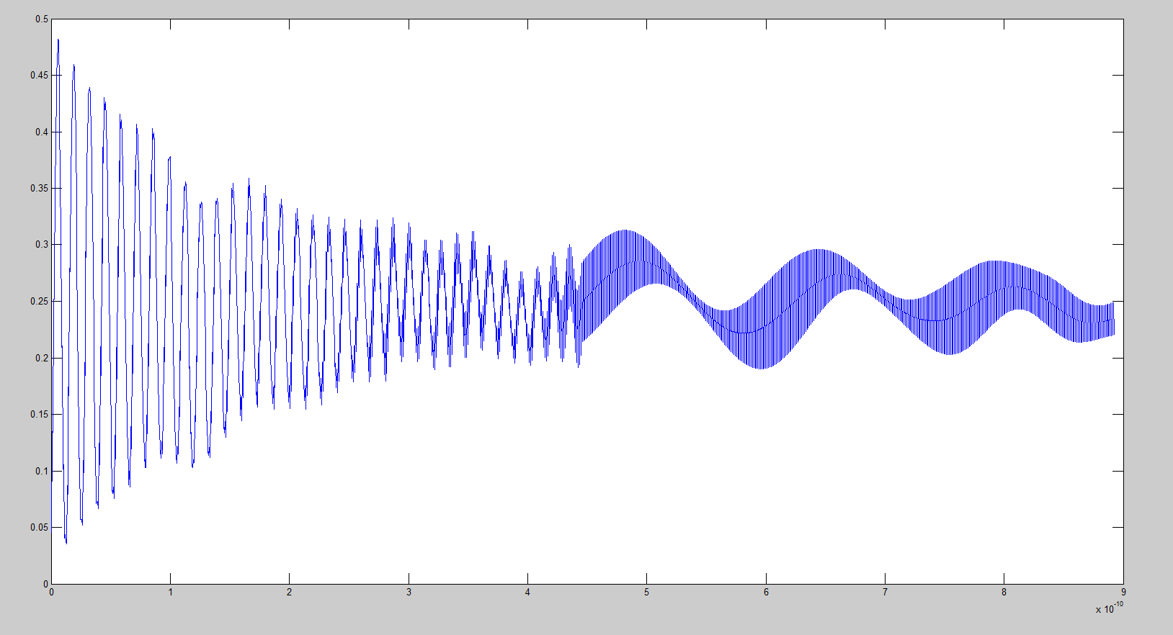The channel impulse response looks like this:

I don’t know if this is a good one. When I use the code in amiinit_1207a_test_i7683 to get the impulse response, it looks much different than the one above. Like:

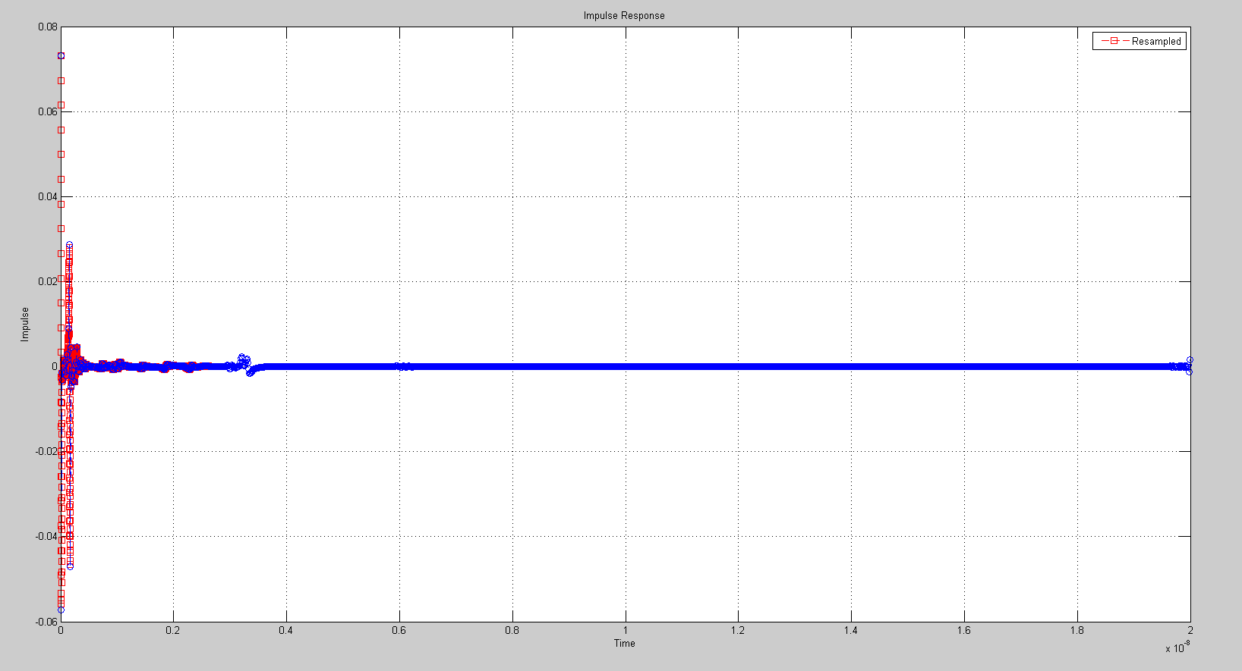

Could you tell me if I made some mistakes?

And another problem, when I run my code in %% IBIS AMI_Init section, the MATLAB just crashed and forced me to exit. I don’t know how to deal with it. However, I can run amiinit_1207a_test_i7683 without this problem.

I need your help.

Yuan Yao

2/11/2015